Day of Pentecost
There two possible gospel readings today, and I have opted to base my selection of music on John 20, v19-23. Jesus appears to his disciples and after greeting them with the customary Jewish greeting of “Shalom” or Peace be with you, after which he breathed on them and said: “Receive the Holy Spirit”.
This simple gesture encapsulates the well-spring of faith and the intangible nature of what we understand by what is the “Spirit of God”.
The concept of the ”Holy Spirit” has challenged and inspired authors and musicians both ancient and modern as we will see in today’s selection.
We start with the ancient hymn “Come, Holy Ghost, our sols inspire” (AM 241). The hymn was written by a German Monk called Rababus Maurus (c780-856) who subsequently became the Bishop of Mainz. The original text consisted of 7 verses written in Latin. The English translation which we use was produced by John Cosin (1594-1672) for the 1662 edition of the Prayer Book. In this form it has been compressed into 4 verses with a short doxology. Cosin was ordained priest c1620 and held various academic (including vice-chancellor of Cambridge University) and church positions (ultimately he was Bishop of Durham).
From its inception this hymn has been used at the season of Pentecost and the ordination of clergy. In this country it was sung at the coronation of Charles I and has been sung at every royal coronation since.
- Come, Holy Ghost, our souls inspire,
and lighten with celestial fire.
Thou the anointing Spirit art,
who dost thy sevenfold gifts impart.
- Thy blessed unction from above
is comfort, life, and fire of love.
Enable with perpetual light
the dullness of our blinded sight.
- Anoint and cheer our soiled face
with the abundance of thy grace.
Keep far from foes, give peace at home:
where thou art guide, no ill can come.
- Teach us to know the Father, Son,
and thee, of both, to be but One,
that through the ages all along,
this may be our endless song:
Praise to thy eternal merit,
Father, Son, and Holy Spirit.
Where Jesus uses breath as a symbol of the Holy Spirit, that is, sustaining life on earth, the symbolism of light and fire in the hymn add discernment and energy to a representation of the Holy Spirit. The attributes and benefits of the Holy Spirit are described in the subsequent verses.
This hymn continues to be sung to an ancient plainsong melody, the origins of which are obscure.
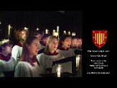
Figure 1 "Come Holy Ghost our solus inspire" AM 241
The anthem we would have used for this Sunday is “Listen sweet Dove” by Grayston Ives. The words are taken from a poem by George Herbert (1593-1633) called Whitsunday published in “The Temple” in 1633. Consisting of seven verses altogether, Ives has selected 4 of them as follows:
Listen sweet Dove unto my song,
And spread thy golden wings in me;
Hatching my tender heart so long,
Till it get wing, and flie away with thee.

Such glorious gifts thou didst bestow,
That th’ earth did like a heav’n appeare;
The starres were coming down to know
If they might mend their wages, and serve here.

The sunne, which once did shine alone,
Hung down his head, and wisht for night,
When he beheld twelve sunnes for one
Going about the world, and giving light.

Lord, though we change, thou art the same;
The same sweet God of love and light:
Restore this day, for thy great name,
Unto his ancient and miraculous right.

We previously encountered George Herbert on the 5th Sunday of Easter where his poem “The Call” was the text of the anthem. I mentioned then that Herbert revelled in word lay and complexity in his poetry and today’s text is no different. Here the reference to the Dove represents the Holy Spirit and Herbert expresses it as a means of giving our souls freedom rather than being just the bringer of the Holy Spirit. The second verse references the way that the Holy Spirit can create heaven on earth, to the extent that the stars, i.e. heavenly bodies want to come to earth to create this earthly heaven. The third verse turns to the role of the disciples as the Jesus’s agents on earth to create this spiritual heaven. The final verse anchors everything to the eternal nature of God.

It is interesting to compare the complexity of Herbert’s poetry with the simple, direct style of Cosin’s translation of “Come Holy Ghost”. Both men were almost exact contemporaries.

The music is by Grayston Ives (1948-) who until March 2009, was Organist, Informator Choristarum and Fellow and Tutor in Music at Magdalen College, Oxford. In this role he was responsible for the daily musical life of the college chapel.

Ives was a chorister at Ely Cathedral and later studied music at Selwyn College, Cambridge, where he held a choral scholarship. After teaching music for a period, he became a member of the King's Singers, from 1978 to 1985

As a composer, Ives' work consists mainly of sacred and secular music for choir, much of it written for the liturgy at Magdalen College, Oxford.

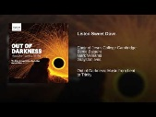
Figure 2 "Listen Sweet Dove unto my song" Grayston Ives
Where the first hymn has been sung regularly for many centuries, the final hymn has had a meteoric rise in popularity and was voted one of the top 10 hymns of the BBC’s Songs of Praise programme in 2019. It is “Be still for the presence of the Lord” (AM 358) by David Evans (1957-). Evans wrote both the words and music taking his inspiration from multiple references in the Psalms and Old testament including the quote “then Jacob awoke from his sleep and said, “surely the Lord is in this place and I did not know”. The hymn was first published in 1985.
Although not written specifically as a Pentecost hymn, the words, capture that moment when Jesus appeared to his disciples and said; “Shalom, Be Still, through my breath you will find the power and Spirit of the Lord”. In the final verse we realise that His spirit and power surrounds us wherever we are gathered or indeed, stuck at home!
- Be still, for the presence of the Lord,
the Holy One is here;
come bow before Him now
with reverence and fear:
in Him no sin is found-
we stand on holy ground.
Be still, for the presence of the Lord,
the Holy One is here.

- Be still, for the glory of the Lord,
is shining all around;
he burns with holy fire,
with splendour He is crowned:
how awesome is the sight-
our radiant King of light!
Be still, for the glory of the Lord,
is shining all around.

- Be still, for the power of the Lord,
is moving in this place:
he comes to cleanse and heal,
to minister His grace.
No work too hard for him,
in faith receive from him,
Be still, for the power of the Lord
Is moving in this place.
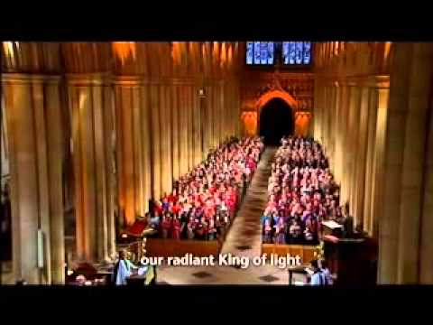
Figure 3 "Be still, for the presence of the Lord" AM 358

